**9.ReactJS-HOL**

**IndianPlayers.js**

import React from "react";

const IndianPlayers = () => {

const players = ["Sachin1", "Dhoni2", "Virat3", "Rohit4", "Yuvaraj5", "Raina6"];

const oddPlayers = players.filter((_, index) => index % 2 === 0);

const evenPlayers = players.filter((_, index) => index % 2 !== 0);

const morePlayers = [

"First Player",

"Second Player",

"Third Player",

"Fourth Player",

"Fifth Player",

"Sixth Player"

];

return (

<div>

<h2>Odd Players</h2>

<ul>

{oddPlayers.map((p, i) => (

<li key={i}>{i === 0 ? "First" : i === 1 ? "Third" : "Fifth"} : {p}</li>

))}

</ul>

<h2>Even Players</h2>

<ul>

{evenPlayers.map((p, i) => (

<li key={i}>{i === 0 ? "Second" : i === 1 ? "Fourth" : "Sixth"} : {p}</li>

))}

</ul>

<h2>List of Indian Players Merged:</h2>

<ul>

{morePlayers.map((p, i) => (

<li key={i}>Mr. {p}</li>

))}

</ul>

</div>

);

};

export default IndianPlayers;

**ListofPlayers.js**

import React from "react";

const ListofPlayers = () => {

const players = [

{ name: "Virat", score: 85 },

{ name: "Rohit", score: 65 },

{ name: "Dhoni", score: 75 },

{ name: "Rahul", score: 45 },

{ name: "Hardik", score: 90 },

{ name: "Jadeja", score: 55 },

{ name: "Shami", score: 72 },

{ name: "Bumrah", score: 40 },

{ name: "Ashwin", score: 88 },

{ name: "Gill", score: 95 },

{ name: "Surya", score: 60 },

];

const playerList = players.map((p, index) => (

<li key={index}>{p.name} - {p.score}</li>

));

const lowScorePlayers = players.filter(p => p.score < 70);

return (

<div>

<h2>List of Players</h2>

<ul>{playerList}</ul>

<h3>List of Players having Scores Less than 70</h3>

<ul>

{lowScorePlayers.map((p, i) => <li key={i}>{p.name} - {p.score}</li>)}

</ul>

</div>

);

};

export default ListofPlayers;

**App.js**

import React from "react";

import ListofPlayers from "./components/ListofPlayers";

import IndianPlayers from "./components/IndianPlayers";

function App() {

const flag = true;

return (

<div className="App">

<h1>Cricket App</h1>

{flag ? <ListofPlayers /> : <IndianPlayers />}

</div>

);

}

export default App;

**Output:**

**When flag is false**

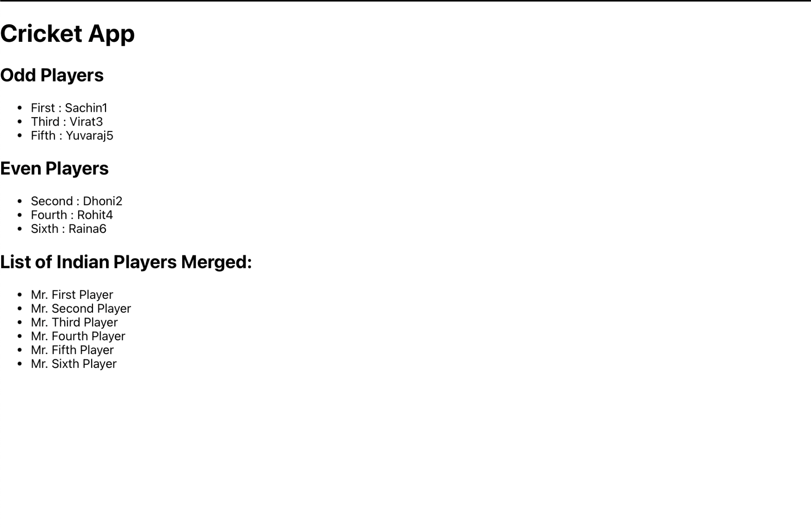

**When flag is true** 